SAFETY INSTRUCTIONS and COURSE MAP FOR COMPETITORS:
RRBC HEAD RACES 2022

These notes should be read in conjunction with British Rowing’s ‘Row Safe’.

COMPETITORS’ RESPONSIBILITIES
All competing crews should ensure that their equipment is 'fit for purpose', paying particular attention to: bow balls, heel release mechanisms, rudder lines and buoyancy compartments/canvases. Marshals may carry out spot checks and race numbers may be withdrawn if boats do not meet the required standards.
- All coxes MUST wear life jackets (or approved buoyancy aids), in accordance with British Rowing’s Row Safe Code.
- All competitors must be able to swim 100 metres in rowing kit.
- All crews must have adequate Third Party insurance.
- All crews must be competent at steering a safe course on the Cam, including being able to give way to faster crews from behind and/or safely overtake slower crews. Less experienced crews MUST provide their own steers person to cycle along with them to help ensure a safe course is steered around bends, obstructions and in over-taking situations.
- All competitors must adhere to any current government COVID-19 guidance

GENERAL SAFETY PROVISIONS
- The organisers will endeavour to provide safe racing, but this does not absolve individual competitors from exercising a duty of care for themselves, any third party and their equipment.
- All marshals will wear fluorescent yellow tabards and will be in radio contact with all other marshals, start and finish.
- Mobile phones will be kept at the start and finish, at Race Control at the CRA Boathouse and most marshals will have one for use in an emergency.
- Competitors are encouraged to provide a bank party to help watch their course and avoiding obstructions and other crews.
- No racing crew is allowed to paddle up stream before the race has started.
- First Aid will be available all day at the Finish and will be contactable via radio. First Aid can be called to the required location via this radio or through contacting the Race Director at the Finish.
- In an emergency, the marshal nearest to the incident will initially take charge. Racing may be stopped until the incident has been resolved. Competing crews must follow the instructions of marshals.
- In an emergency, final decisions on appropriate actions will be the responsibility of the Race Director at the Finish. All marshals will promptly inform the Race Director of any emergencies and seek confirmation of appropriate responses.

ADVERSE WEATHER

FOG OR OTHERWISE REDUCED VISIBILITY
In the event of fog or otherwise reduced visibility making racing unsafe, the organisers may delay, suspend, or cancel racing. This will be clearly communicated to crews at the boathouse areas.

HIGH WIND, SNOW, HEAVY RAIN etc
In the event of adverse weather such as High Wind, Snow, Heavy Rain, the organisers may delay, suspend, or cancel racing. This will be clearly communicated to crews at the boathouse areas. In the event of racing going ahead in less-than-ideal conditions (e.g.: moderate winds), it is up to coaches to assess whether any particular crew is capable of coping with conditions. Crews not deemed capable of safely competing in such conditions may withdraw and will receive a full refund.

LIGHTNING PLAN
If a thunderstorm occurs during the event, the provisions laid down in the document “Recommendations for Lightning Protection in Sport” (available from British Rowing) shall be followed if feasible: “Suspension and resumption of rowing shall follow the 30/30 rule: rowing shall stop when the flash-to-bang count is 30 seconds, and shall not resume until 30 minutes after the last lightning”.
Ideally crews will be cleared from the water and shepherded back to the boathouses or to a safe landing place in the bank by marshals as rapidly as possible.
Marshals will instruct all athletes, officials and spectators to move into their vehicles or into a suitable building.
The 30-30 rule should give sufficient time to clear all crews from the river safely.
Any Marshal observing lightning, shall inform the Race Director and Race Control immediately; marshals will instruct crews to return to the boathouses or to a safe area of the bank as quickly and as safely as possible.
However, it is recognised that there is negligible safe shelter adjacent to the further reaches of the Cam and that crews may well be safer staying in their boats than standing exposed on the (higher) bank. Whether they are directed to stay stationary in their boats, drawn in to the bank; to pull in to the bank and get out under shelter; or to return to the boathouses, will depend on where crews are on the river when lightning is first observed.

The oranisers reserve the right to amend this plan on the day if weather or conditions on the day make this necessary. In which case, or if the event has to be cancelled, the information will be communicated to crews at the boathouse areas and posted on social media/the website.

COURSE
• A plan of the course is attached showing the positions of marshals.
- Crews are warned that there is a weir below the start.

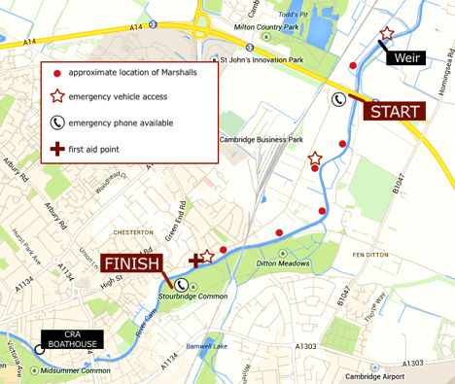

POSITION REFERENCES FOR EMERGENCY SERVICES (what3words.com)

Quote the relevant 3-word reference if calling emergency services

- CRA boathouse (Kimberley Road) – down.dream.ages
- CRA boathouse (Logan’s Way) – state.foil.stay
- Green Dragon Bridge – solved.native.slug
- Finish (Stourbridge Common) – snack.improving.loving
- P+E (towpath access point from Water Street) – sung.minus.milk
- Grassy Corner (towpath access) – singer.reef.closed
- Start (A14 Bridge) – capacity.scorching.loaning
- Baits Bite Lock – plums.thinker.alpha
- Fen Road (towpath access) – contain.existence.encourage
Useful telephone numbers

Emergency Services | 999
Addenbrooke's Hospital A&E  01223 217118 | 01223 217118
Cambridge Constabulary (non- emergency) | 101
East of England Ambulance Service | (emergencies should use 999)  0845 601 3733
Local GPs Surgeries:
• 96 Chesterton Rd. (Red House) | 0844 477 3124
• 125 Newmarket Rd. | 01223 358961
Cam Conservators (river management) | 01223 863785
Cam Conservators (emergency/out of hours) | 01223 646459
Environmental Agency hotline for environmental incidents | 0800 807060

