SAFETY INSTRUCTIONS FOR COMPETITORS: RRBC AUTUMN HEAD - 2016

These notes should be read in conjunction with British Rowing’s ‘Row Safe’.
COMPETITOR'S RESPONSIBILITIES
All competing crews should ensure that their equipment is 'fit for purpose', paying particular attention to: bow balls, heel release mechanisms, rudder lines and buoyancy compartments/canvases. Umpires may carry out spot checks and race numbers may be withdrawn if boats do not meet the required standards.
- All coxes MUST wear life jackets (or approved buoyancy aids), in accordance with British Rowing’s Row Safe Code.
- All competitors must be able to swim 100 meters in rowing kit.
- All crews must have adequate Third Party insurance.
- All crews must be competent at steering a safe course on the Cam, including being able to give way to faster crews from behind and/or safely overtake slower crews. Less experienced crews MUST provide their own steers person to cycle along with them to help ensure a safe course is steered around bends, obstructions and in over-taking situations.
SAFETY
- All race marshals will wear fluorescent yellow tabards stating 'MARSHAL', also be in radio contact with all other race marshals, start and finish. In an emergency, the race marshal nearest to the incident will initially take charge. Racing may be stopped until the incident has been resolved. Competing crews must follow the instructions of marshals and umpires.
- In an emergency, Final decisions on appropriate actions will be the responsibility of the Race Director at the Finish. All marshals will promptly inform the Race Director of any emergencies and seek confirmation of appropriate responses. No racing crew is allowed to paddle up stream before the race has started. The organisers will endeavour to provide safe racing, but this does not absolve individual competitors from exercising a duty of care for themselves, any third party and their equipment. Competitors are again encouraged to provide a bank party to help watch their course and avoiding obstructions and other crews. First Aid will be available all day at the Finish and will be contactable via radio. First Aid can be called to the required location via this radio or through contacting the Race Director at the Finish.

COURSE
• A plan of the course is attached showing the positions of race monitors.
- Crews are warned that there is a weir (Baits Bite Lock) below the start.

PHONES
- Mobile phones will be kept at the start and finish, at Race Control at the CRA Boathouse and most marshals will have one for use in an emergency.
SAFETY INSTRUCTIONS FOR COMPETITORS: RRBC AUTUMN HEAD - 2016

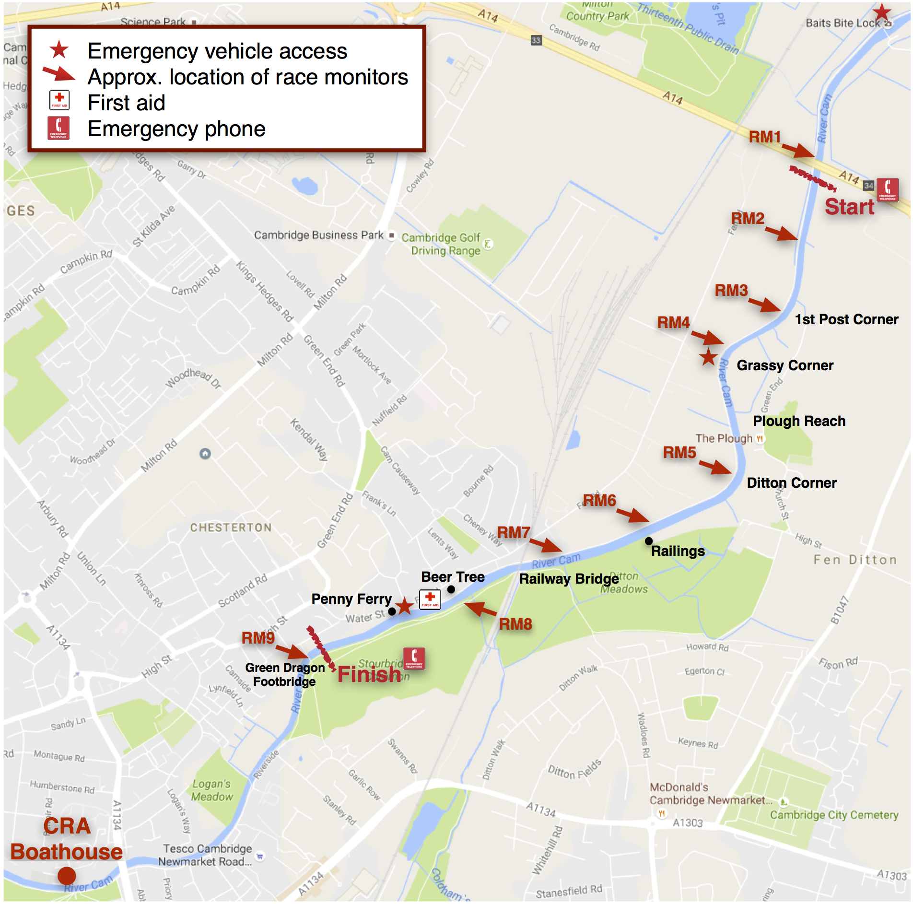

OS GRID REFERENCES
Quote the relevant grid reference if calling emergency services to help them come to the right location on the river:
CRA boathouse (Kimberley Road) | TL456 592
Combined Boathouse (Logan’s Way) | TL463 592
Road access to Stourbridge Common via Riverside | TL 466 595
Road access to Stourbridge Common via Garlic Row | TL 468 596
Finish area on Stourbridge Common | TL 468 599
Tow path access point from Water Street and First Aid Point | TL470 600
Tow path access point from Baits Bite Lock | TL486 621
Start (A14 Motorway Bridge) | TL484 616

SAFETY INSTRUCTIONS FOR COMPETITORS: RRBC AUTUMN HEAD - 2016 USEFUL NUMBERS

Emergency Services | 999
Addenbrooke's Hospital A&E | 01223 217118
Cambridge Constabulary (non- emergency) | 101
East of England Ambulance Service | (emergencies should use 999) 0845 601 3733
Local GPs Surgeries:
• 96 Chesterton Rd. (Red House) | 0844 477 3124
• 125 Newmarket Rd. | 01223 358961
Cam Conservators (river management) | 01223 863785
Cam Conservators (emergency/out of hours) | 01223 646459
Environmental Agency hotline for environmental incidents | 0800 807060

